
The Oaks Medical Centre Newsletter

NEW WEBSITE: www.theoaksmedical.co.uk
We have recently launched our new website which we hope patients will find informative and ready to use.

Our Doctors:

- Dr J. Naik
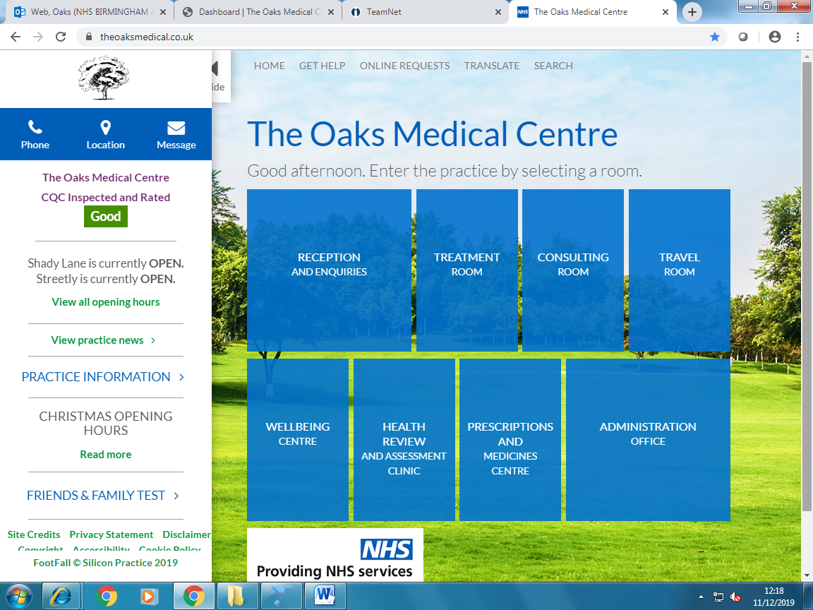
- Dr G. Khaira
- Dr A. Lewis
- Dr K. Gordon
- Dr A. Long
- Dr A. Philip
- Dr J. Lee
- Dr R. Rafi
- Dr M. Gulamhusein
- Dr J. Patter
DID NOT ATTEND (DNA) Appointments
Throughout December 2019 there were
272 wasted appointments.
- This occurred as a result of patients not informing the practice that they were unable to attend a booked appointment.

PLEASE, PLEASE, PLEASE, if you are not able to attend a booked appointment let the Surgery know at your earliest convenience. This is so we can then offer the appointment to another patient.

Patients can cancel appointments via:
- Telephone
- Online Service
- Website: www.theoaksmedical.co.uk
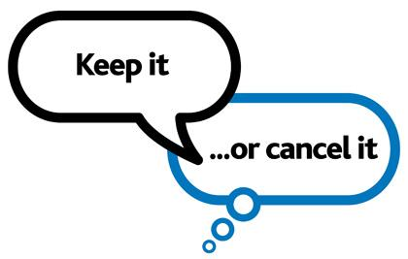
Your mobile number enables us to text you a reminder of your appointment where there is also an opportunity to cancel the appointment if necessary.

Contents Page:

New Website/DNAs | 1
MMR Catch-up/Vaccinations | 2
Extended Hours/PLT | 2
Carers/Staff News | 3

travellin

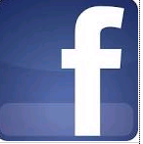
please visit & like our awareness page on facebook:
http://www.facebook.com/oaks-medical-centre-health-awareness-page-730851727088253/

MMR CATCH UP FOR 10-11 YEAR OLDS

Measles activity has increased globally, including in the UK since 2017. It is important that efforts are stepped up to ensure that everyone is up to date with their MMR vaccination. In April 2019, NHS England and the BMA General Practitioners Committee (GPC) agreed to a catch-up campaign for the Measles, Mumps and Rubella (MMR) vaccine. The Catch-up campaign is for children who reached the age of 10 or 11 years on or after the 1st September 2018 but who have not yet reached the age of 12 years. Please contact the Surgery on 0121 389 2222 for further information.


PNEUMOCOCCAL VACCINATIONS

Certain people are more susceptible to infection with this bug; they are termed “at risk” and include the following:
- Individuals aged 65 and over
- Individuals with a serious long term medical condition (e.g. Heart Disease, Diabetes and COPD)
- Individuals who may have had their spleen removed.

A practice nurse will be able to advise whether you are eligible for a Pneumococcal vaccination. For more information contact the surgery to discuss your eligibility for the Pneumococcal Vaccination
INFLUENZA VACCINATION

IT’S NOT TOO LATE TO HAVE YOUR FLU VACCINATION. PLEASE BOOK YOUR APPOINTMENT NOW!!

EXTENDED HOURS



Evening and weekend appointments are now available for patients who are registered with this GP practice.

The appointments will take place Oaks Medical Centre, 199 Shady Lane, Great Barr, B44 9ER

Appointments must be booked in advance through the reception team at this surgery and are available with a range of clinicians including GPs and Nurses.

Appointments times are:

Monday- Friday 6.30pm- 8.00pm

Saturday 9.00am- 1.00pm

For more information please speak to reception.

PLT (PRACTICE LEARNING TIMES)

The practice closes once a month at 1pm for mandatory training. We are however covered by the OUT OF HOURS service. During this time, if you need a doctor urgently please call the surgery on 0121-389-2222 and your call will be diverted to OUT OF HOURS.

Some PLT dates for 2020:

Wednesday 22nd January 2020

Wednesday 12th February 2020

Wednesday 18th March 2020

Wednesday 29th April 2020

Wednesday 20th May 2020

WHO IS CONSIDERED A CARER?
A Carer is anyone, including children and adults who looks after a family member, partner or friend who needs help because of their illness, frailty, disability, a mental health problem or an addiction and cannot cope without their support. The care they give is unpaid. When we refer to carers in this document, this is inclusive of both adult and young carers. Many carers don’t see themselves as carers and it takes them an average of two years to acknowledge their role as a carer (NHS website: Understanding Carers).
It can be difficult for carers to see their caring role as separate from the relationship they have with the person for whom they care, whether that relationship is as a parent, child, sibling, partner or friend. It’s likely that every one of us will have caring responsibilities at some time in our lives with the challenges faced by carers taking many forms. Many juggle their caring responsibilities with work, study and other family commitments. Some, in particular younger carers, are not known to be carers. They don’t tell relatives, friends or health and care professionals about their responsibilities because of a fear of separation, guilt, pride or other reasons. It is very helpful for the Practice to know that you are a carer. If you have not informed the practice please speak to the receptionist or fill out a carers form via the website: www.theoaksmedical.co.uk

STAFF NEWS
We would like to introduce our new members of staff.
Jodie Byrne – Receptionist
Ravina Patter – Secretary
Samantha Bakewell – Paramedic
Social Prescriber -This involves helping patients to improve their health, wellbeing and social welfare by connecting them to community services which might be run by the council or a local charity. For example, signposting people who have been diagnosed with dementia to local dementia support groups. Recognising that people’s health is determined primarily by a range of social, economic and environmental factors, social prescribing seeks to address people’s needs in a holistic way. It also aims to support individuals to take greater control of their own health. For more info please speak to the GP.
Scrivens (Hearing Test) - We now run a dedicated hearing clinic at this surgery for all patients over 55 with a hearing loss. The clinic can supply NHS Digital Hearing Aids, if required.

Please ask at reception to book a hearing screening appointment.

Alternatively, call 0800 027 5102 to find out more about NHS hearing care and how you can access this service locally.



